**Lampiran 1 Lembar Kegiatan Bimbingan Laporan TA**

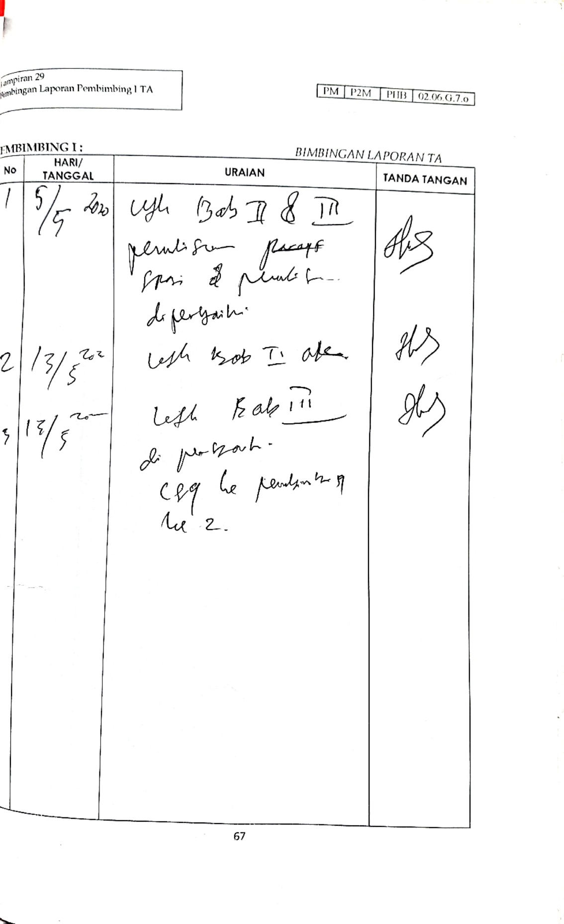

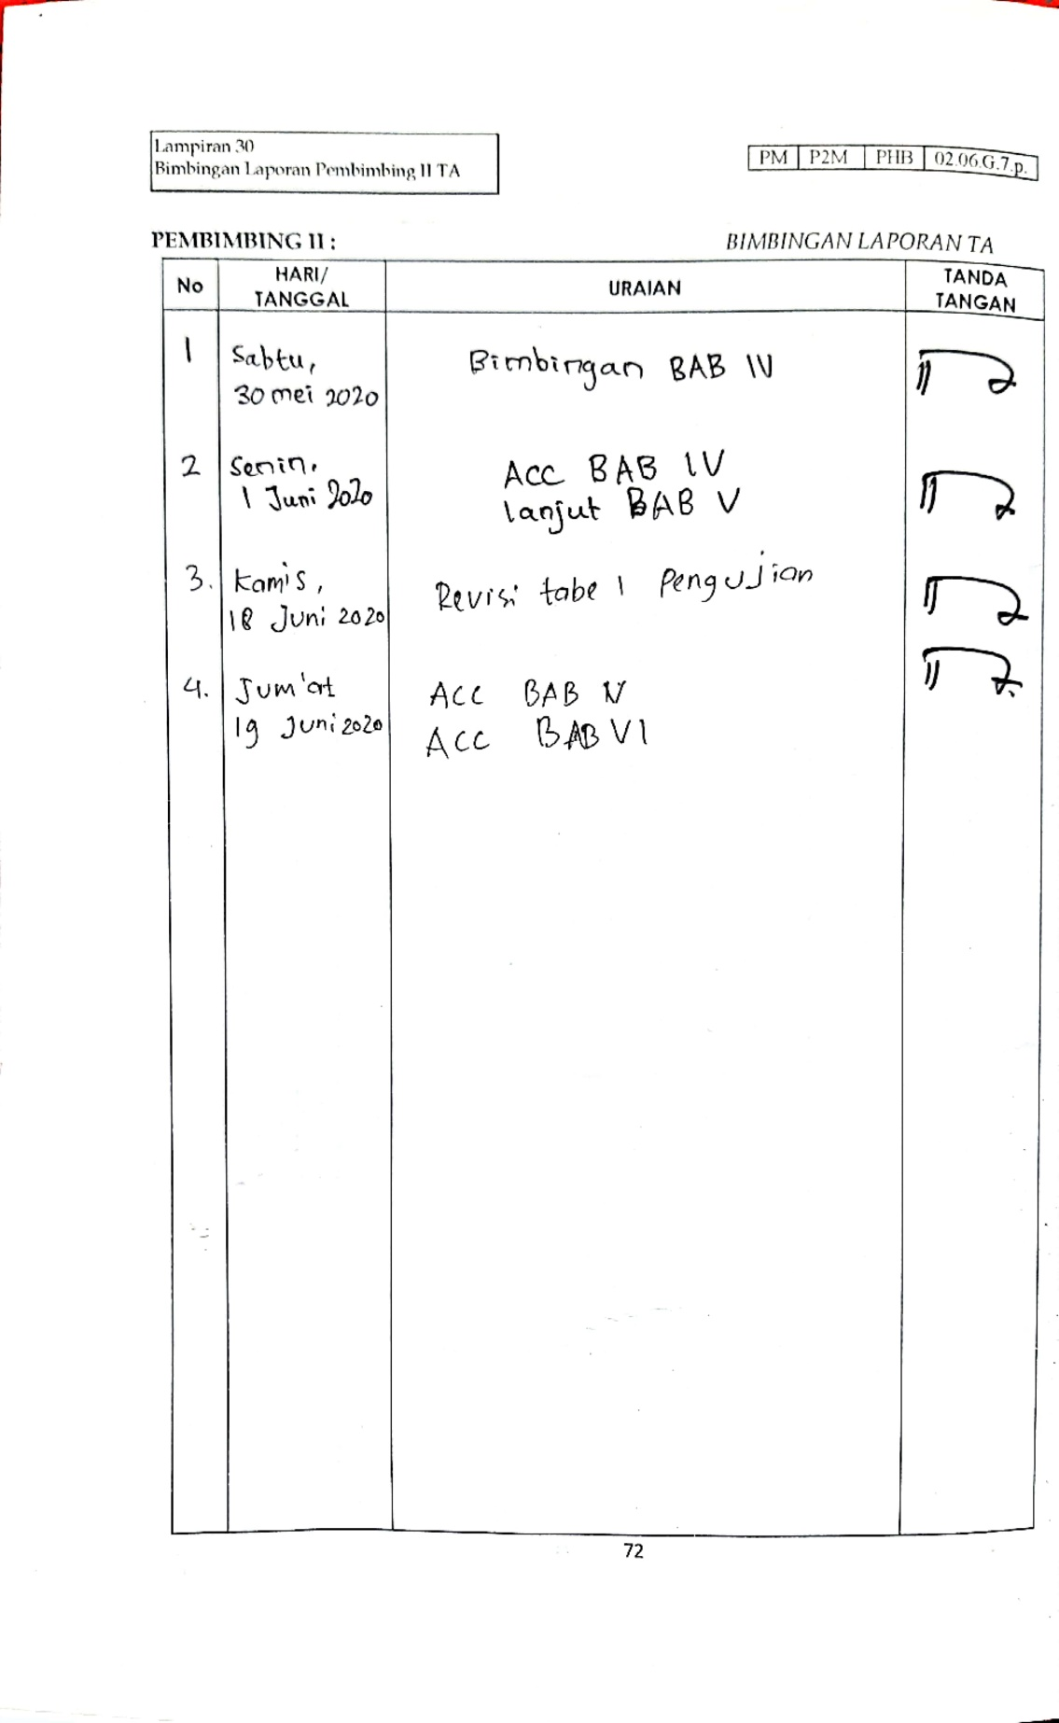

**Lampiran 2 Surat Kesediaan Membimbing TA**

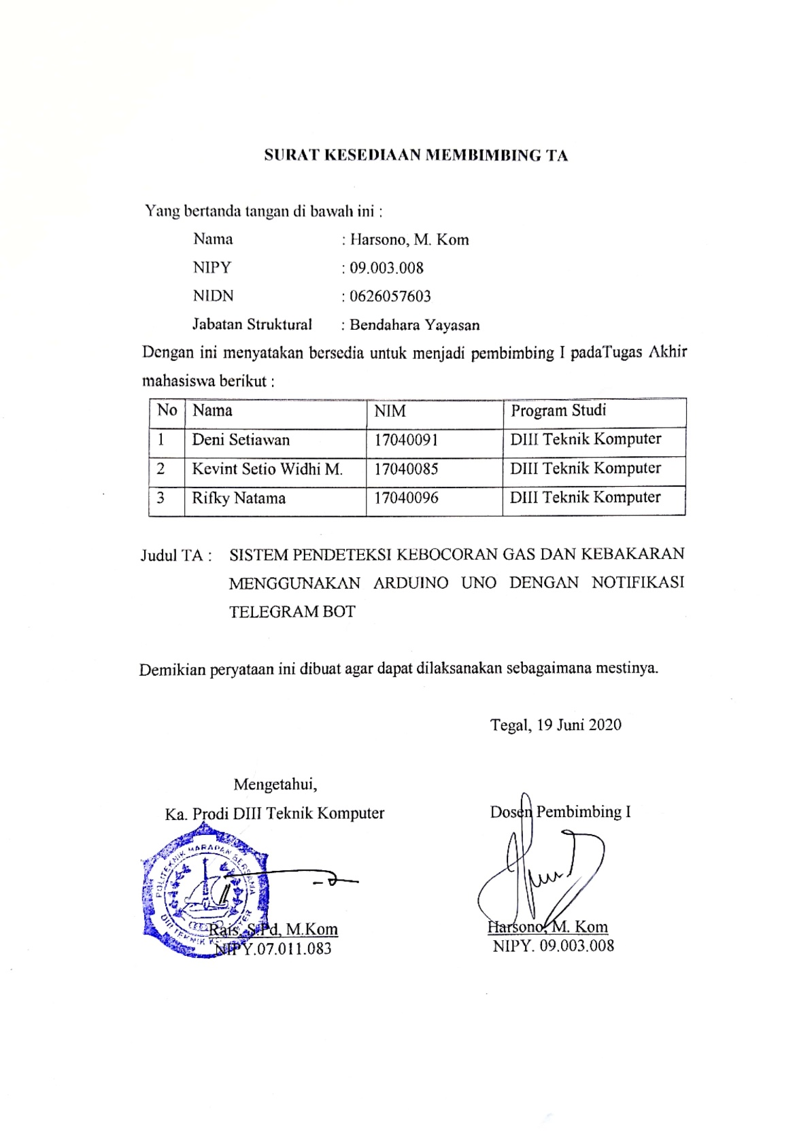

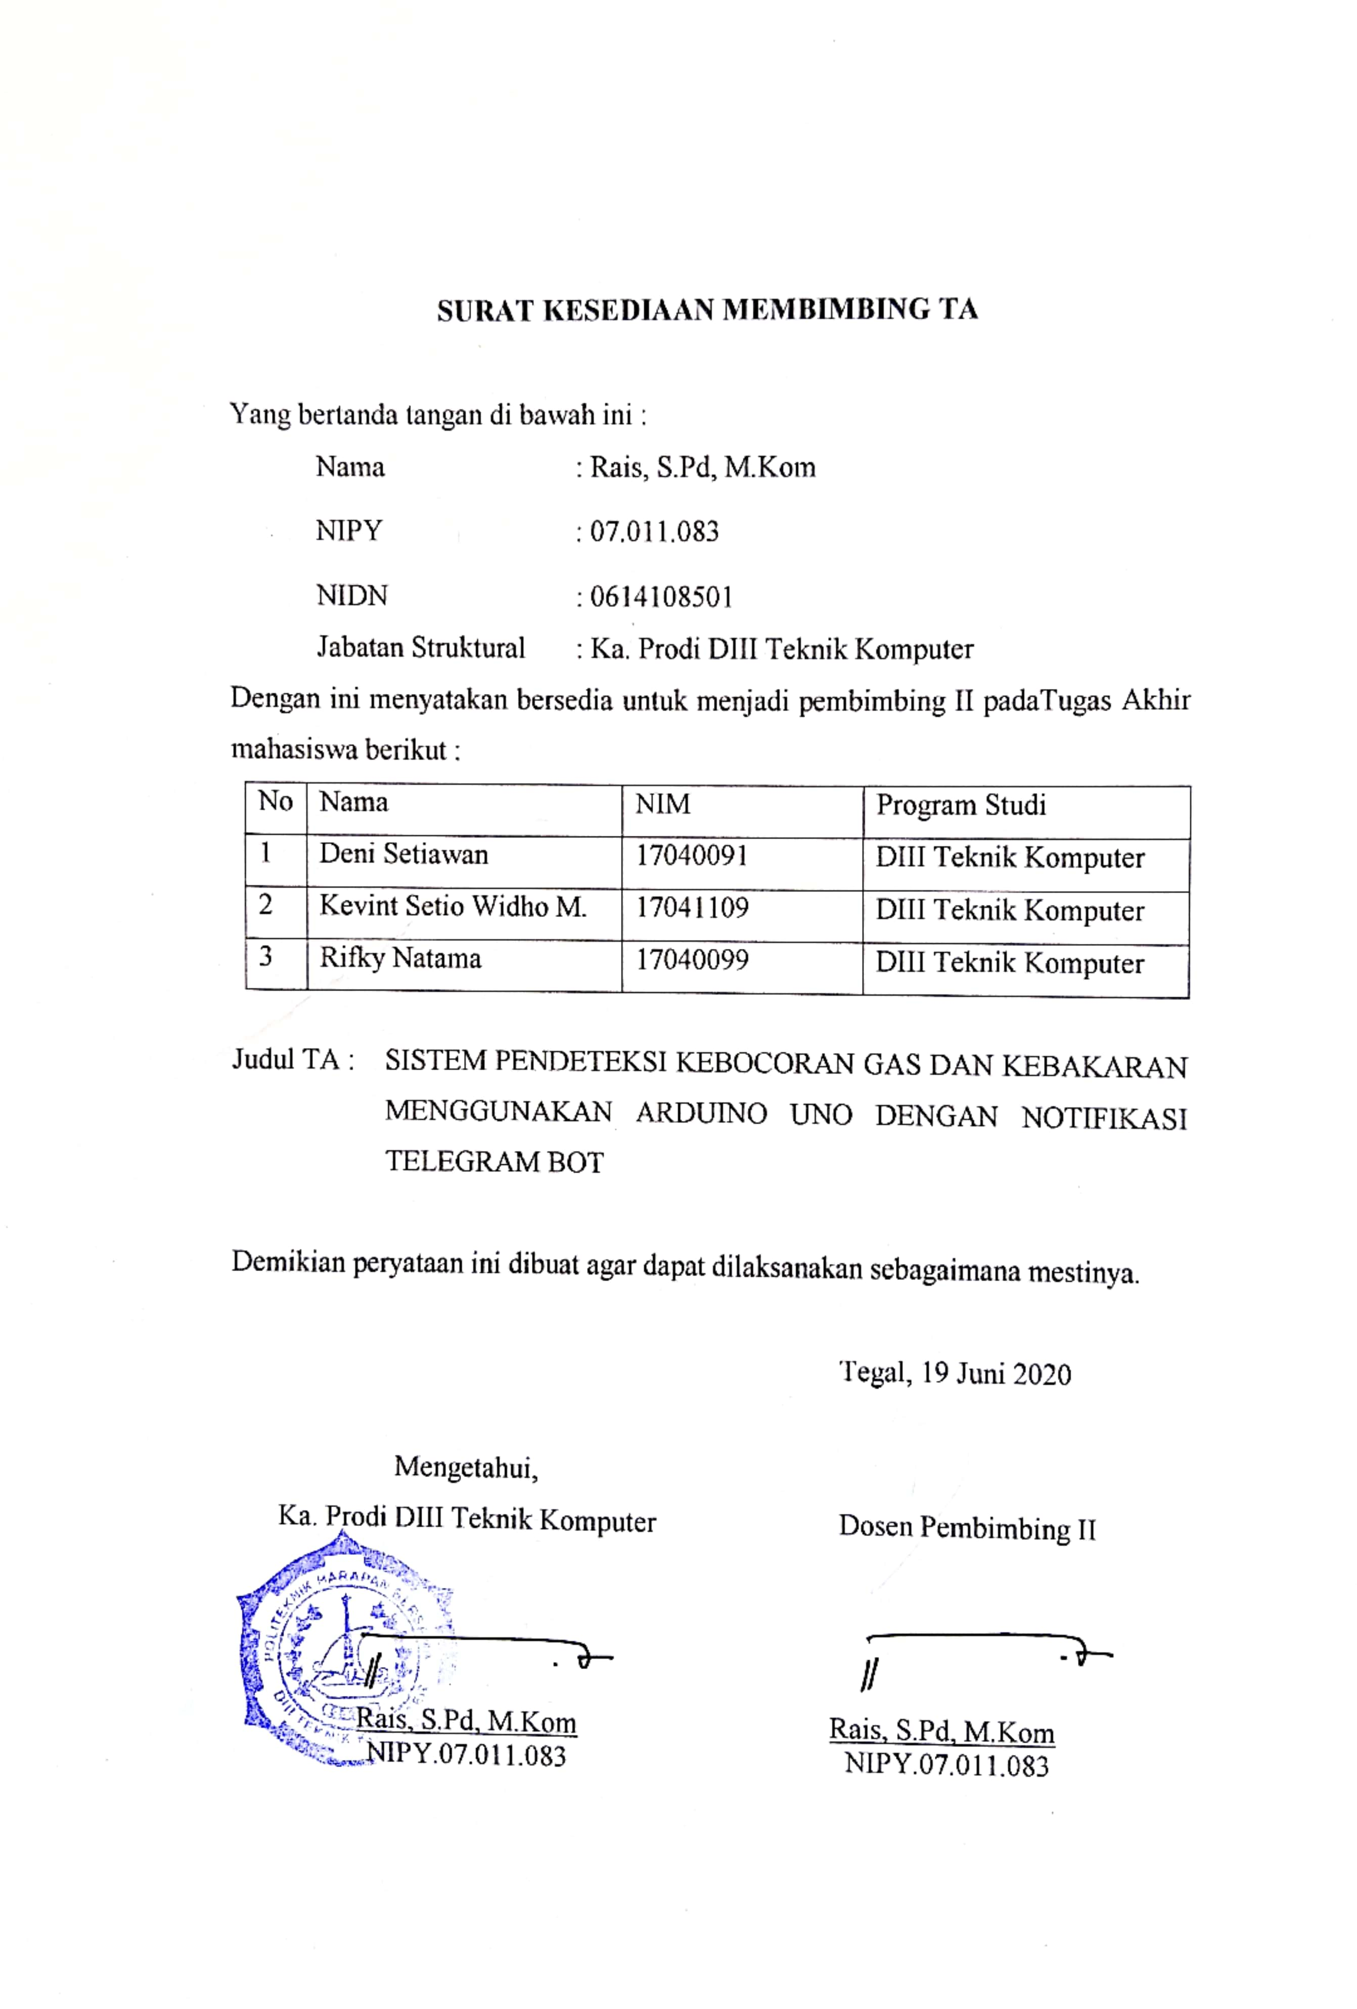

**Lampiran 3 Lembar Penilaian Bimbingan TA**

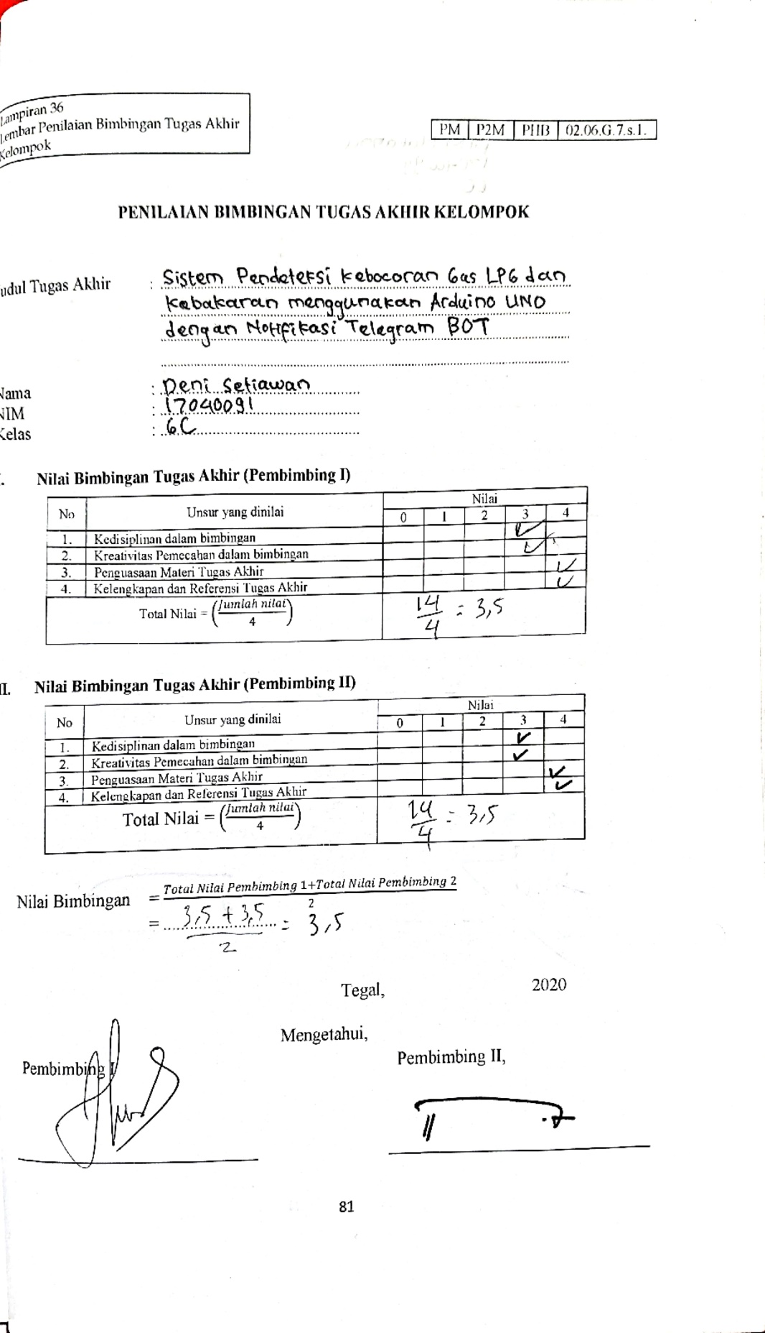

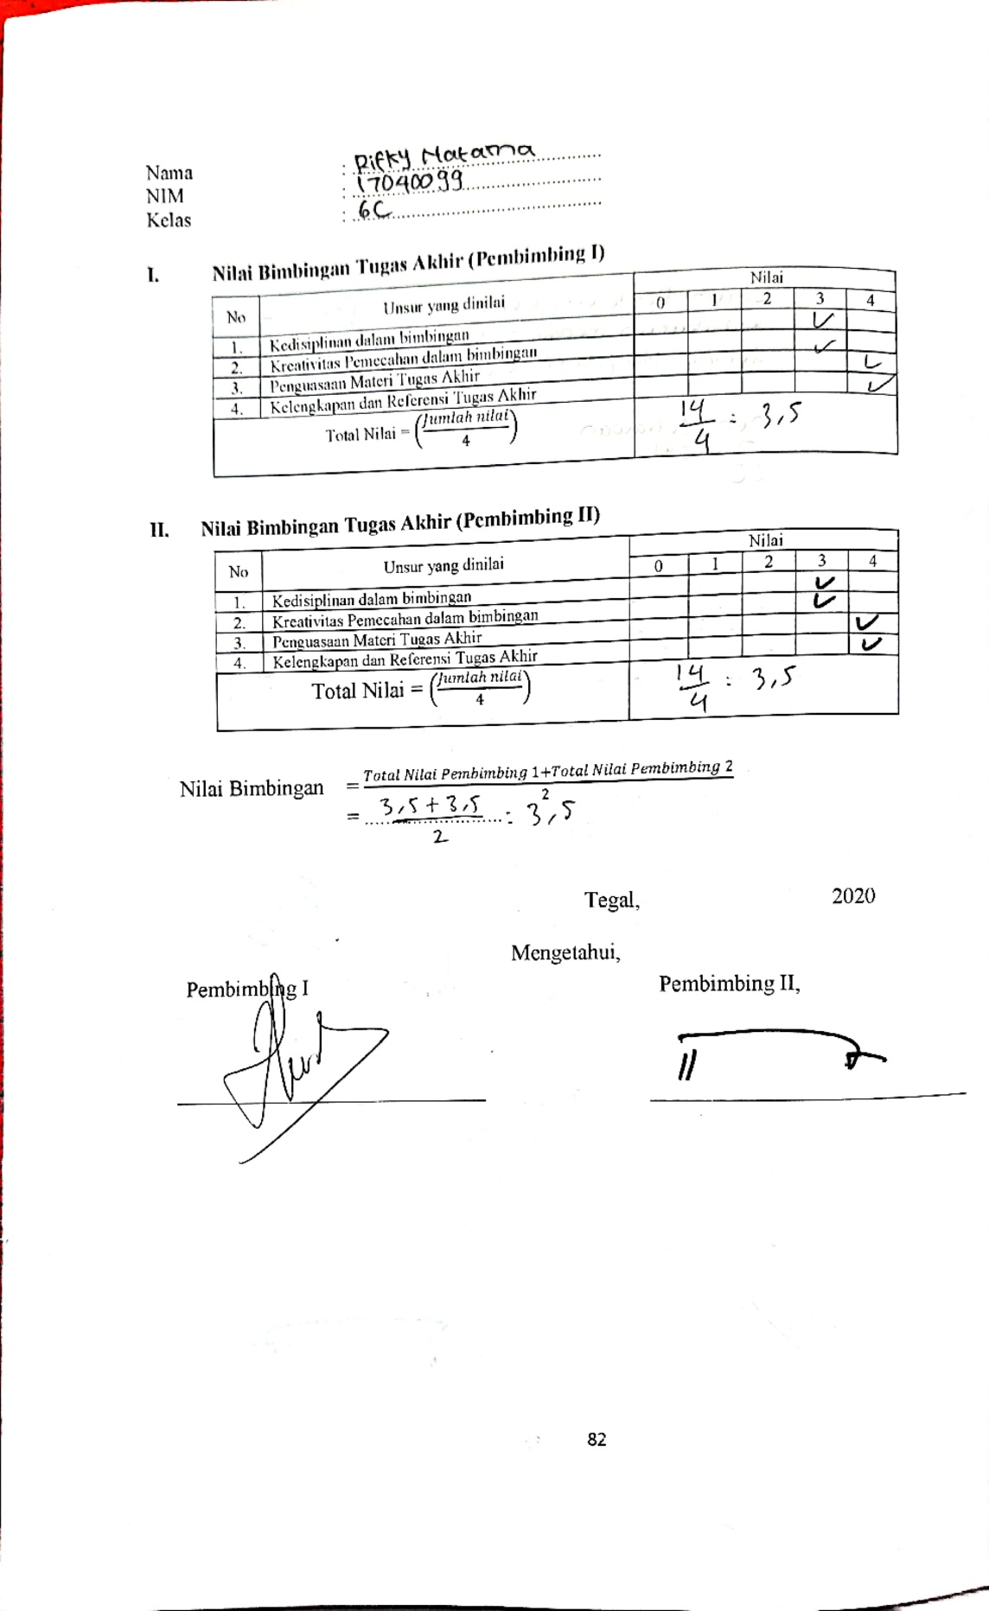

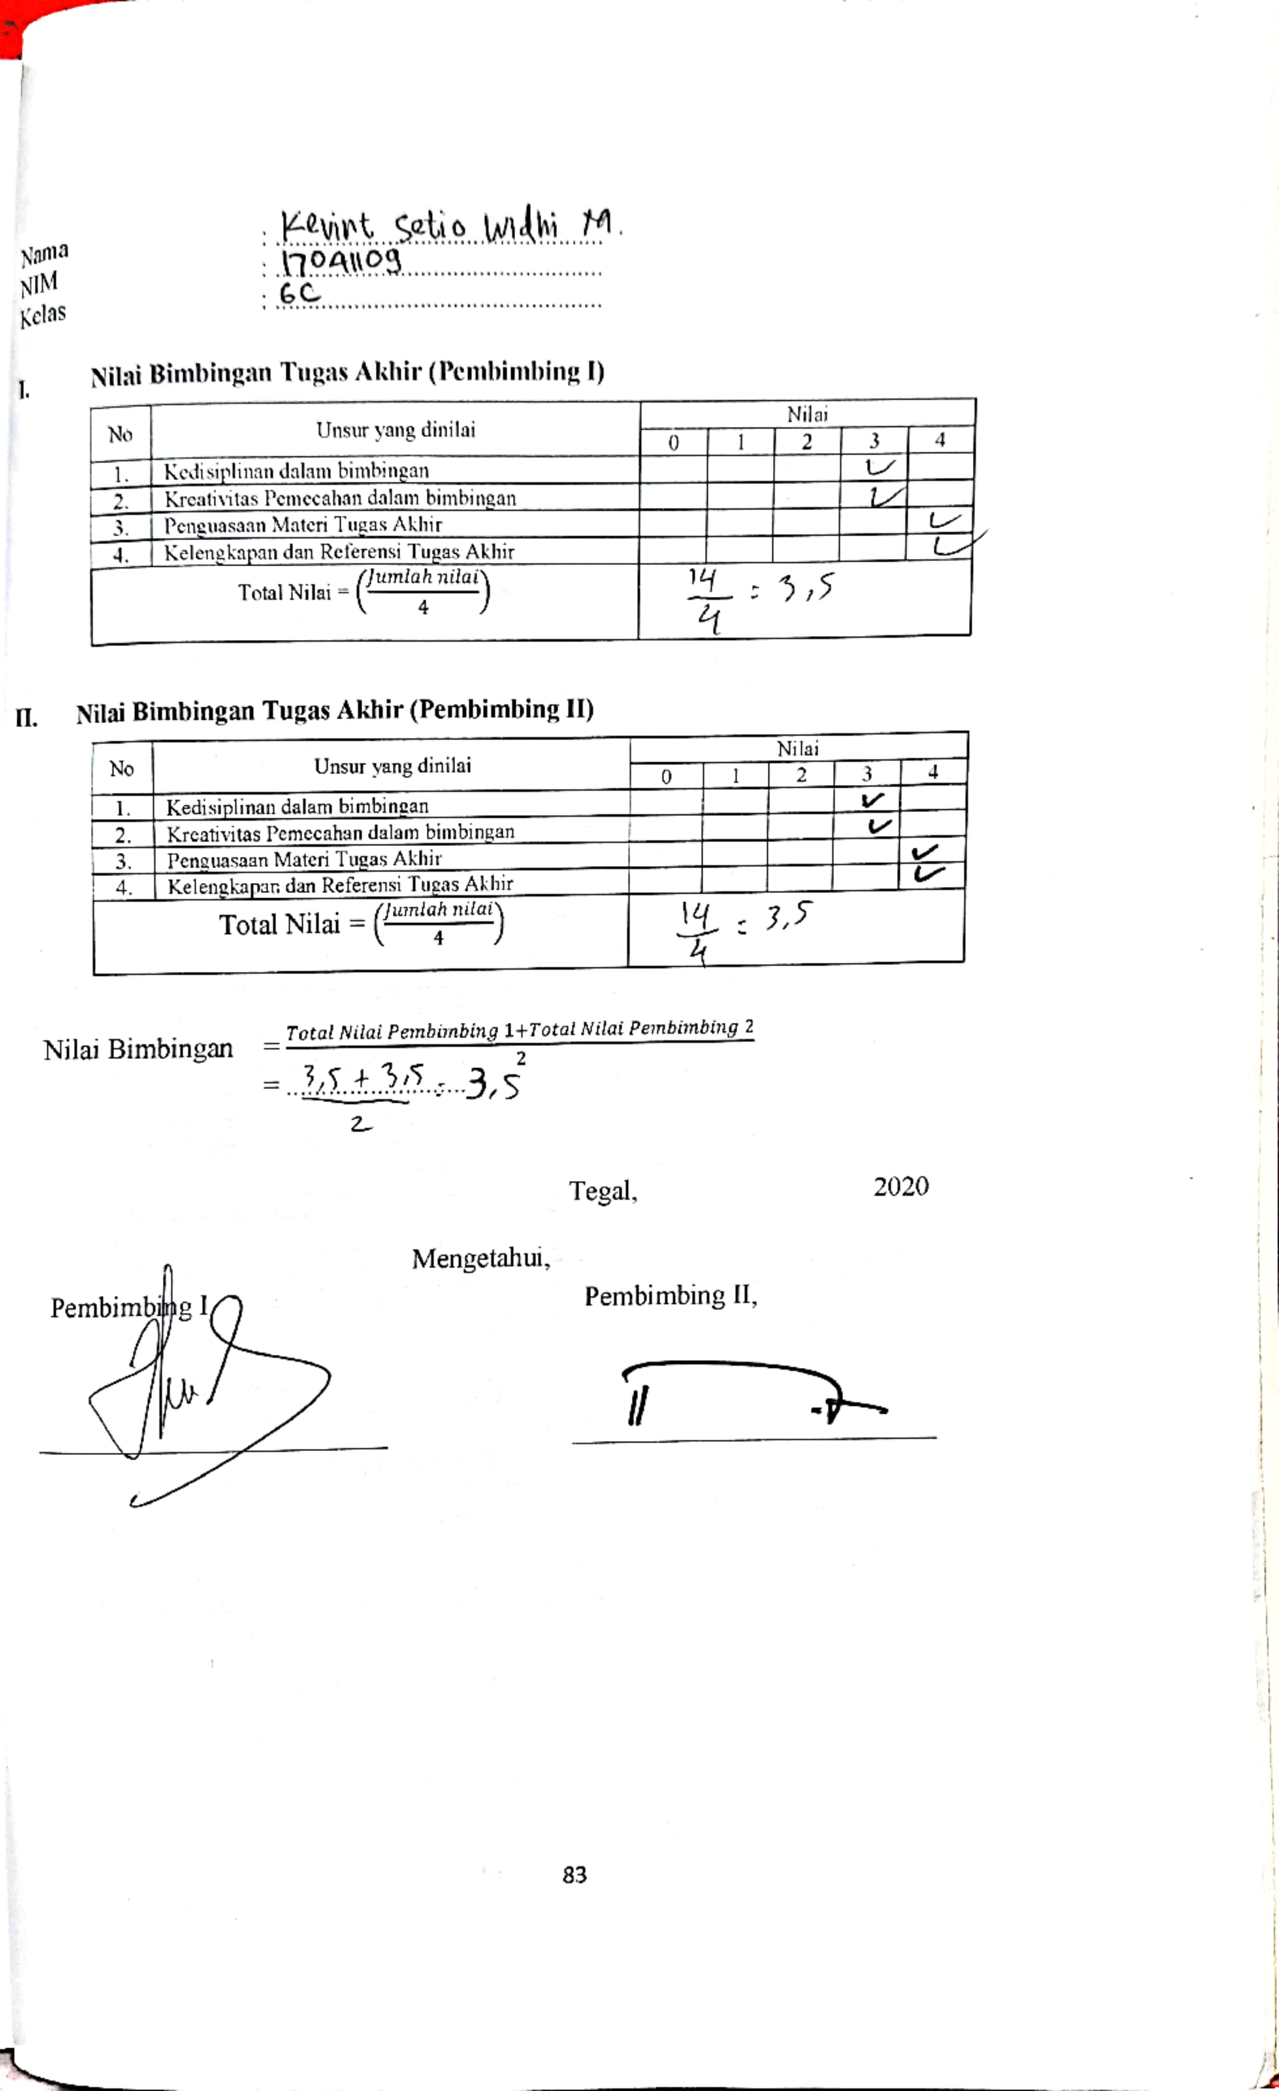

**Lampiran 4 Listing Program**

* + - 1. **Program Arduino UNO**

**#include <Wire.h>**

**//sensor gas**

**#include <MQ2.h>**

**#define gasPin A0**

**#define pin8 8 //Notif kipas**

**//sensor api**

**const int pin2 = 2;**

**#define pin9 9**

**#define pin6 6//Notif buzzer**

**int bacasensorApi = 0;**

**#include <SoftwareSerial.h>**

**SoftwareSerial wifi(A3, A2);//atau pin 16 dan 15**

**String str;**

**void setup() {**

**//Set serial monitor pada 9600**

**Serial.begin(9600);**

**wifi.begin(115200);//serial untuk nodeMCU**

**//gas**

**pinMode(pin9, OUTPUT);**

**pinMode (pin8, OUTPUT);**

**//PIR**

**pinMode(4, INPUT);**

**pinMode(5, OUTPUT);**

**//api**

**pinMode(pin2, INPUT);**

**pinMode(pin6, OUTPUT);**

**}**

**void loop() {**

**{**

**str = "";//reset string**

**//if(digitalRead(4) == HIGH){**

**//}**

**//else { noTone(5);**

**//}**

**//pir / gerak**

**// if (digitalRead(4) == HIGH) {**

**// Serial.println("Motion Detected");**

**// digitalWrite(5, HIGH);**

**//**

**// str = String(str) + String("Terdeteksi Gerakan\n");**

**// } else {**

**// Serial.println("No Motion");**

**// digitalWrite(5, LOW);**

**// }**

**bacasensorApi = digitalRead(pin2);**

**//Serial.println(bacasensorApi);**

**if (bacasensorApi == LOW) {**

**// turn Buzzer on:**

**digitalWrite(pin6, HIGH);**

**str = String(str) + String("Terdeteksi Panas Api\n");**

**Serial.println(bacasensorApi);**

**} else {**

**// turn Buzzer off:**

**digitalWrite(pin6, LOW);**

**}**

**int gasSensor = analogRead(gasPin);**

**if (gasSensor > 550) {**

**digitalWrite(pin9, HIGH);**

**digitalWrite (pin8, LOW);**

**str = String(str) + String("Gas = ") + String(gasSensor) + String(" ppm\n");**

**str = String(str) + String("Terdeteksi Kebocoran Gas\n");**

**Serial.println(gasSensor);**

**} else {**

**digitalWrite(pin9, LOW);**

**digitalWrite(pin8, HIGH);**

**}**

**//kirim pesan ke nodeMCU**

**wifi.println(str);**

**delay(1000);}**

**}**

* + - 1. **Program NodeMCU**

**#include <CTBot.h>**

**#include <ESP8266WiFi.h>**

**#include <WiFiClientSecure.h>**

**#include <UniversalTelegramBot.h>**

**CTBot myBot;**

**String ssid = "Kedai Kopi MIACATES";**

**String password = "tembemcinta";**

**String token = "1211515132:AAHDnIUPJJ-r5UsT2U64WhlR3WhvREZN4TM" ;**

**const int id = 901543448;**

**WiFiClientSecure client;**

**UniversalTelegramBot bot(token, client);**

**String str;**

**void setup() {**

**// Open serial communications and wait for port to open:**

**Serial.begin(115200);**

**//kirim pesan**

**WifiStatus();**

**myBot.wifiConnect(ssid,password);**

**myBot.setTelegramToken (token);**

**if (myBot.testConnection()) {**

**Serial.println("koneksi Bagus");**

**} else {**

**Serial.println("Koneksi Jelek");**

**}**

**myBot.sendMessage (id, "NodeMcu ON");**

**Serial.println("pesan Terkirim ke Telegram");**

**}**

**void loop() { // run over and over**

**if (Serial.available()) {**

**str = Serial.readString();**

**myBot.sendMessage(id, str);**

**//Serial.println(str);**

**//Serial.write(Serial.read());**

**}**

**}**

**void WifiStatus() {**

**WiFi.mode(WIFI_STA);**

**WiFi.disconnect();**

**delay(100);**

**Serial.print("Connecting Wifi: ");**

**Serial.println(ssid);**

**WiFi.begin(ssid, password);**

**while (WiFi.status() != WL_CONNECTED) {**

**Serial.print(".");**

**delay(500);**

**}**

**Serial.println("");**

**Serial.println("WiFi connected");**

**Serial.print("IP address: ");**

**Serial.println(WiFi.localIP());**

**}**